 

**AN INTERNSHIP REPORT**

***Submitted by***

**RAHUL J - 412422118037**

***In Partial fulfillment for the award of the degree***

***of***

***BACHELOR OF ENGINEERING***

***in***

# COMPUTER AND COMMUNICATION ENGINEERING

**SRI SAI RAM INSTITUTE OF TECHNOLOGY (AUTONOMOUS), SAI LEO NAGAR, CHENNAI-44**

**ANNA UNIVERSITY : CHENNAI 600 025**

# JUNE - 2024

**BONAFIDE CERTIFICATE**

Certified that this internship report "**Company Web Page**" the Bonafide works of "**RAHUL J - 412422118037**" who carried out the internship works in the "**Mindful AI** ".

Dr. S. RAJARAJAN, PROFESSOR DEAN/ACADEMICS

DR. M. PACHHAIMMAL ALIAS PRIYA,

PROFESSOR

HEAD OF THE DEPARTMENT

Dr. K. Pavendan

AP, INTERN COORDINATOR

Mrs. L. KANNAGI AP, TALENT ENABLER

Mr. M. S. ULAGANATHAN, STRATEGIST,

AP, PLACEMENT FACILITATOR

Mrs. A. AMBIKA,

AP, STUDENT MENTOR

MR. M.S ULAGANATHAN ,

AP, STRATEGIST

Submitted for internship review held on at Sri Sai Ram Institute of Technology, Chennai - 600044

# DETAILS OF INTERNSHIP

|  |  |  |  |
| --- | --- | --- | --- |
| **SECTION NUMBER** | **COMPANY NAME** | **MODE OF INTERNSHIP** | **YEAR / SEM** |
| I | MINDFUL AI | OFFLINE | II / IV |

**SECTION - I**

# TABLE OF CONTENTS

|  |  |  |
| --- | --- | --- |
| **S. NO.** | **TITLE** | **PAGE NO.** |
| 1. | ABSTRACT | 1 |
| 2. | ABOUT THE COMPANY | 2 |
| 3. | ABOUT THE INTERNSHIP   * 1. OBJECTIVE   2. MOTIVATION | 3 |
| 4. | COMPANY LANDING PAGE   * 1. PROPOSED SOLUTION   2. DESIGN METHODOLOGY   3. FEATURES   4. PROTOTYPE   5. TECH STACK   6. SOURCE CODE | 5 |
| 5 | IMPACT OF THE INTERNSHIP | 21 |
| 6. | PROOF OF COMPLETION | 22 |
| 7. | RESULT AND CONCLUSION | 23 |

**CHAPTER - 1 ABSTRACT**

During my internship at MindFul AI, I was immersed in a vibrant learning environment focused on providing holistic experiences tailored to meet industry demands. Through hands-on experience in front-end development, I contributed to creating user-friendly interfaces. The 15-day training, spanning from June 05,2024 to June 20, 2024, was instrumental in enhancing my technical expertise and fostering invaluable teamwork and project management skills.

My internship at MindFulAI provided me with a rich learning experience that has significantly contributed to my professional development. Immersed in a dynamic environment, I gained practical insights into React JS, honed my technical skills, and learned to work effectively in a team setting. This project allowed me to take ownership of a significant initiative, further enhancing my leadership abilities and project management skills.

Furthermore, the hands-on experience I gained during the internship has been invaluable in preparing me for future challenges in the field of both React JS and Figma.

# CHAPTER - 2 ABOUT THE COMPANY

**NAME OF THE COMPANY: MINDFUL AI**

# CIN: U72900UP2019PTC124729

MindFulAI Technologies Pvt Ltd - A Product and Service based Private Limited Company with a well-equipped team that works on various technologies.We have been awarded the Most Trustable Startup 2024.

The aim of MindFul AI is to promote economy, employment, and enable community- oriented innovations. We encourage innovative projects from all stages starting from ideation, early traction, validation, and scaling. The Company vision is to be the main force behind digital transformation, enabling companies to reach their maximum potential by fusing human innovation with the combined power of technology . In the digital age, we want to redefine sectors, improve user experiences and take businesses to levels never before achieved by developing innovative solutions. We also conduct extensive training on different technological aspects and other services required for startups and innovators.

**Internship Period:** 05/06/2024 to 20/06/2024 (15 Days)

**Mode of Internship:** Offline



# CHAPTER - 3 ABOUT THE INTERNSHIP

* 1. **OBJECTIVE**

To leverage the skills acquired during the intensive 15-day training period in VS Code, React JS, to contribute to the development of innovative and user-centric applications. By applying these skills effectively, I aim to enhance user experiences, streamline processes, and deliver solutions that meet the ever- evolving demands of the digital landscape.

My objective is to collaborate closely with cross-functional teams, including designers, developers, to translate project requirements into robust, scalable, and aesthetically pleasing user friendly applications. Through effective communication, problem-solving, and attention to detail, I aspire to play a pivotal role in delivering high-quality software products that resonate with users and drive positive outcomes for businesses and organizations.

I am committed to upholding best practices in software development, including code quality, performance optimization, to ensure that the applications I contribute to are reliable, efficient, and user-friendly. By adhering to industry standards and embracing a mindset of continuous improvement, I seek to elevate the overall quality of the products I work on and contribute to the success of the teams and projects I am involved in.

# MOTIVATION

The training I received providing me with a comprehensive understanding of VS code, React JS and front-end development techniques. This knowledge has not only equipped me with the necessary skills but has also instilled in me a strong motivation to apply these competencies in practical scenarios and contribute to the development of cutting-edge mobile applications. The experience gained from these projects has inspired me to seek out new challenges, collaborate with diverse teams, and leverage my expertise to create impactful solutions that address the evolving needs of users across various domains.

Witnessing the tangible results of my efforts through functional and user-friendly applications has been immensely rewarding. I am driven by the satisfaction of seeing my work positively impact users' lives and am eager to continue making meaningful contributions to the field.

Moreover, I am dedicated to ongoing learning and growth in this dynamic industry. Recognizing the rapid pace of technological advancements and shifts in user preferences, I am committed to staying updated with the latest technologies and industry trends. Through continuous learning and adaptation, I aim to deliver top-notch solutions that not only meet but exceed user expectations.

# CHAPTER - 4 COMPANY LANDING PAGE

**OUTLINE OF THE PROJECT:**

The project was initiated with the objective of designing and developing a visually appealing, user-friendly, and functional company landing page that accurately represents the company’s brand and values, while also serving as a robust platform for user engagement and interaction. The first step in the project involved conducting an in-depth analysis of the company's goals, target audience, and competitors to understand the market landscape and identify key elements that would differentiate the landing page. This research was crucial in shaping the overall strategy and design approach.

In the planning phase, a detailed project plan was developed, outlining the timeline, key milestones, and deliverables. Wireframes and mockups were created to visualize the layout, color scheme, typography, and overall aesthetic of the landing page. These design elements were carefully selected to ensure consistency with the company's brand identity and to create a visually cohesive look and feel. User experience (UX) and user interface (UI) design principles were meticulously applied to ensure intuitive navigation, ease of use, and accessibility for all users, including those with disabilities.

# PROPOSED SOLUTION

Our proposed solution encompasses a multifaceted approach to revolutionize ATM security while prioritizing user experience and convenience. At the core of our system lies a sophisticated facial detection and recognition mechanism, meticulously developed using state-of-the-art machine learning algorithms and computer vision techniques. Leveraging Python's extensive libraries such as OpenCV and TensorFlow, we aim to create a robust model capable of accurately identifying individuals based on their unique facial features. This model will be trained on a diverse dataset to ensure reliability across various demographics and environmental conditions.

In tandem with facial recognition, our system will integrate seamlessly with a MySQL database to securely store user biometric data and transaction records. Utilizing industry-standard encryption protocols and access control mechanisms, we will safeguard sensitive information against unauthorized access and potential breaches. Additionally, real-time monitoring functionalities will be implemented to detect and mitigate suspicious activities, further enhancing the system's resilience against fraudulent behavior.

User interaction with the ATM interface will be streamlined and intuitive, with the facial recognition process seamlessly integrated into the transaction workflow. Upon approaching the ATM, users will be prompted to position themselves within the camera's field of view for authentication. The system will then analyze the captured image, comparing it against the stored biometric data to verify the user's identity. Upon successful authentication, users will gain access to their accounts and be able to perform desired transactions swiftly and securely.

# DESIGN METHODOLOGY

The proposed solution for designing the company landing page involves a multi- phase approach, ensuring that each aspect of the project is meticulously planned, executed, and optimized to meet the company’s goals and user expectations.

The initial phase focuses on understanding the company’s objectives, target audience, and competitive landscape. Comprehensive research will be conducted to gather insights into user preferences, industry trends, and competitor strategies.

The design phase begins with creating wireframes and mockups to visualize the layout, structure, and aesthetic of the landing page. The design will prioritize a clean, modern look that reflects the company’s brand identity. Color schemes, typography, and imagery will be selected to evoke the desired emotional response and enhance brand recognition. User Experience (UX) and User Interface (UI) design principles will be applied to create an intuitive and accessible navigation structure, ensuring that users can easily find the information they need. Interactive elements, such as call-to-action buttons and animated graphics, will be incorporated to engage users and encourage interaction.

In the development phase, the landing page will be built using modern web technologies such as HTML, CSS, and JavaScript. Responsive design techniques will be employed to ensure that the landing page functions seamlessly across all devices, providing a consistent user experience on desktops, tablets, and smartphones. Advanced CSS techniques and JavaScript libraries, such as Bootstrap and React, will be utilized to create a dynamic and interactive user interface. The landing page will include essential features such as contact forms, social media integration, and newsletter subscription forms to facilitate user engagement and

data collection.

Once development is complete, the landing page will undergo rigorous testing to ensure functionality, compatibility, and performance. Cross-browser testing will be conducted to verify that the landing page performs well on all major browsers, including Chrome, Firefox, Safari, and Edge. Mobile testing will ensure that the page is fully responsive and user-friendly on various mobile devices. Usability testing sessions with real users will be organized to gather feedback and identify any areas for improvement.

# FEATURES

Here are the key features of the proposed ATM system utilizing facial recognition technology:

**Responsive Design:** Implementation of a design that adapts seamlessly to various screen sizes and devices, providing a consistent user experience on desktops, tablets, and smartphones. Flexible grid layouts and media queries to adjust content dynamically based on device dimensions. Mobile-first design approach to ensure the site performs well on mobile devices from the outset.

**Biometric Data Storage**: A clean, visually appealing layout with a modern design that reflects the company's brand identity and values. Use of white space to enhance readability and focus on key elements. Incorporation of modern design trends such as flat design, material design, or neomorphism

**Call to Action**: Easy-to-use contact forms to facilitate user inquiries and feedback, with fields for name, email, message, and other relevant information. CAPTCHA or other anti-spam measures to protect the form from automated submissions. Integration with email marketing or CRM systems for lead management.

**Social Media Integration:** Integration of social media links and widgets to encourage users to connect with the company on various social platforms. Display of live social media feeds to showcase recent posts and user interactions. Social sharing buttons to allow users to easily share content on

their own social media profiles.

**Testimonials :** Display of customer testimonials and case studies to build credibility and trust with potential clients. Video testimonials or quotes from satisfied customers. Detailed case studies that showcase successful projects and client outcomes.

**Product/Service Information**: Detailed information about the company’s products or services, including features, benefits, and pricing.

Comparison charts and FAQs to help users make informed decisions. Downloadable resources such as brochures or whitepapers.

**Interactive Elements:** Inclusion of interactive elements such as sliders, carousels, and hover effects to enhance user engagement. Interactive infographics and charts that respond to user inputs. Video backgrounds or embedded videos to provide dynamic content.

.

# PROTOTYPE

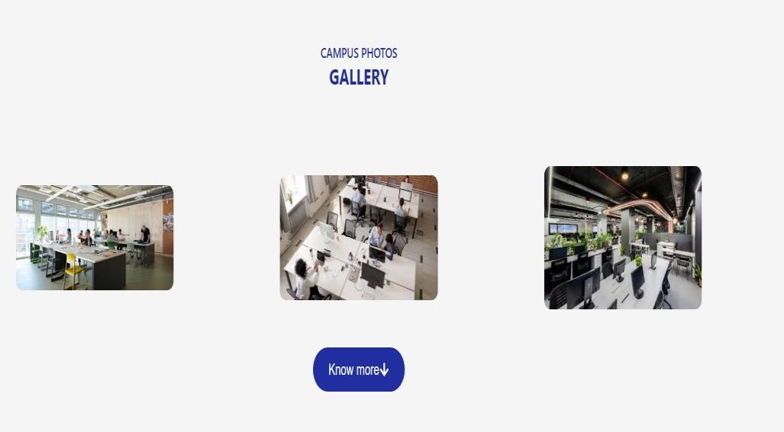

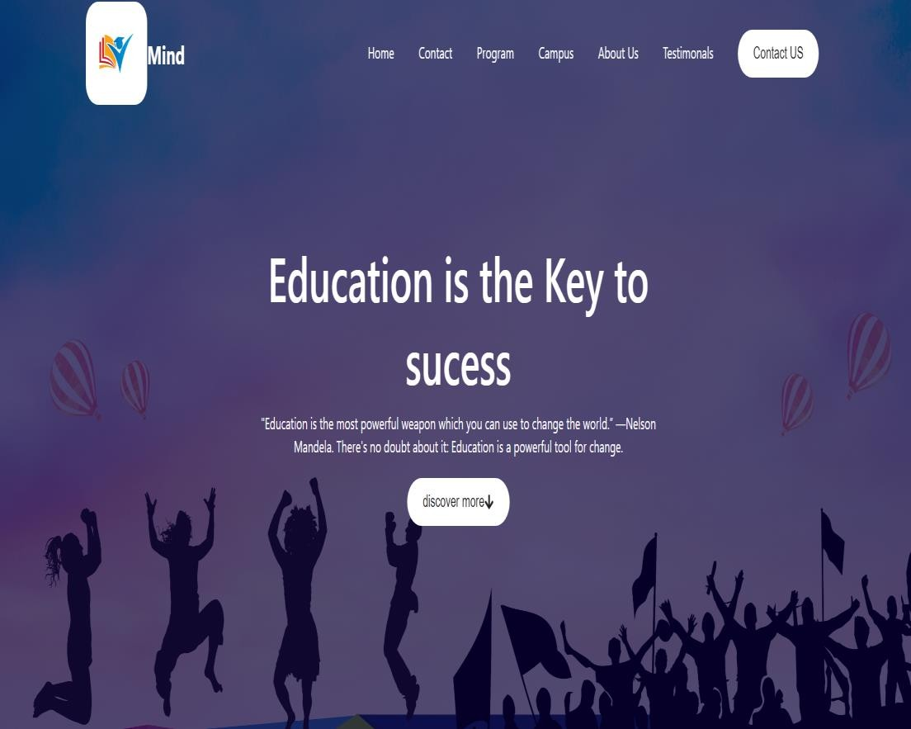

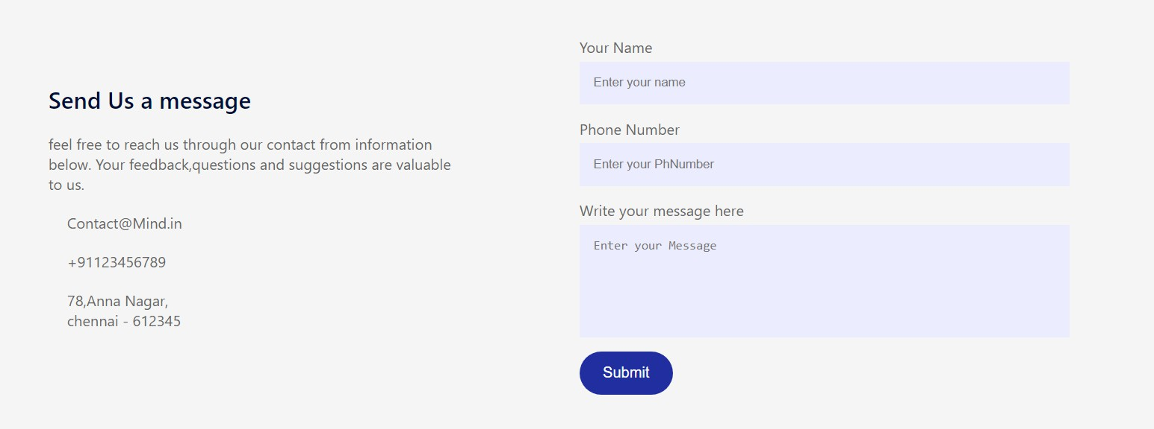

* 1. **TECH STACK**

The technical stack of the proposed Company Landing Page technology encompasses a combination of HTML, CSS ,React JS frameworks

**React JS:** React JS component-based architecture allowed for the creation of reusable UI components. Each part of the landing page, such as the header, footer, navigation menu, and content sections, was built as a separate component. This modularity made the development process more manageable and facilitated code reusability. For instance, the contact form and call-to-action buttons were developed as components that could be easily integrated and reused across.

**State Management:** State management in React.js was handled using React's built-in state management features along with the Context API for global state. This approach enabled efficient handling of dynamic content and user interactions. For example, the state of form inputs, such as user name and email in the contact form, was managed locally within the component, while global states, like theme settings and user authentication status, were managed using Context API. This ensured that the application responded quickly to user inputs and changes without unnecessary re-renders.

**React Router:** React Router was integrated to manage the navigation between different sections of the landing page. This provided a seamless user experience, allowing users to navigate without full page reloads. The routing setup included paths for the homepage, product/service details, blog, and contact sections.

Dynamic routing was used to handle pages such as individual blog posts and product details, improving the overall user experience.

**Styling:** Styling in React.js was achieved using CSS-in-JS libraries such as styled- components. This approach allowed for writing CSS directly within JavaScript, scoped to individual components. This prevented style conflicts and made it easier to manage and maintain the styles. Styled-components also provided theming capabilities, enabling consistent styling across the landing page and easy customization.

**Form Handling:** For form handling, libraries like Formik and Yup were used in conjunction with React.js. Formik simplified the process of creating and managing forms, while Yup provided a robust schema-based validation solution. This combination ensured that form inputs were validated correctly and errors were handled gracefully, improving the overall user experience.

# SOURCE CODE:

import React, { useRef } from 'react'

import "./testimonals.css"

import { MdNavigateNext } from "react-icons/md";

import { IoIosArrowBack } from "react-icons/io";

import ITProfessional from "../../assets/ITProfessional.jpg" import Professional from "../../assets/Professional.jpg" import Professional1 from "../../assets/Professional1.jpg"

const Testimonals = () => { const slider = useRef() let tx=0;

const Forward = ()=>

{

if(tx> -50)

{

tx-=25;

}

slider.current.style.transform =

`translateX(${tx}%)`

}

const Backward = ()=>

{

if(tx < 0)

{

tx+=25;

}

slider.current.style.transform =

`translateX(${tx}%)`

}

return (

<div className='testimonals'>

<IoIosArrowBack style={{ padding:"10px", color:"black"

}} className='prev-btn' onClick={Backward} />

<MdNavigateNext className='next-btn' onClick={Forward} />

<div className='slider'>

<ul ref={slider}>

<li>

<div className='slide'>

<div className='user-info'>

<img src={ITProfessional} width={65} height={65} />

<div>

<h3>Adam</h3>

<span>Bangalore</span>

</div>

</div>

<p>

"Education is the most powerful weapon which you can use to change

the world.” —Nelson Mandela.

There's no doubt about it: Education is a powerful tool for change.

</p>

</div>

</li>

<li>

<div className='slide'>

<div className='user-info'>

<img src={Professional} width={65} height={65} />

<div>

<h3>Vijay</h3>

<span>Chennai</span>

</div>

</div>

<p>

"Education is the most powerful weapon which you can use to change

the world.” —Nelson Mandela.

There's no doubt about it: Education is a powerful tool for change.

</p>

</div>

</li>

<li>

<div className='slide'>

<div className='user-info'>

<img src={Professional1} width={65} height={65} />

<div>

<h3>Suriya</h3>

<span>Mumbai</span>

</div>

</div>

<p>

"Education is the most powerful weapon which you can use to change

the world.” —Nelson Mandela.

There's no doubt about it: Education is a powerful tool for change.

</p>

</div>

</li>

</ul>

</div>

</div>

)

}

export default import React, { useState } from 'react'

import "./contact.css" const ContactUS = () => {

const [result,SetResult] = useState("")

const handleSubmit = async(e)=>

{

e.preventDefault(); SetResult("Sending ")

const formData = new FormData(e.target)

formData.append("ac") const res = await

fetch("https://api/web3forms.com/s ubmit",{

method:"POST", body:formData,

}).then((res)=> res.json())

}

return (

<div className='contact'>

<div className='contact-col'>

<h3>

Send Us a message

</h3>

<p>

feel free to reach us through our contact from

information below. Your feedback,questions and suggestions

are valuable to us.

</p>

<ul>

<li>

[Contact@Mind.in](mailto:Contact@Mind.in)

</li>

<li>

+91123456789

</li>

<li>

78,Anna Nagar,

<br>

</br>

chennai - 612345

</li>

</ul>

</div>

<div className='contact-col'>

<form>

<label>Your Name</label>

<input type='text' name='name' placeholder='Enter your name' required

/>

<label>Phone Number</label>

<input type='tel' name='phone' placeholder='Enter your PhNumber' required />

<label>Write your message here</label>

<textarea name='message' id='' rows={"6"} placeholder='Enter your Message' required >

</textarea>

<button className='btn dark-btn'>

Submit

</button>

</form>

{

result &&

<span> sending

</span>

}

</div>

</div>

)

}

export default ContactUS

# CHAPTER – 5 IMPACT OF THE INTERNSHIP

During my internship, I seamlessly transitioned from a design-focused role to a multifaceted contributor, engaging in project coordination, ideation, and implementation. While my primary responsibility remained the UI/UX design, I actively participated in various aspects of the project to ensure its success.

My dedication to crafting an exceptional user experience led me to spearhead the UI/UX aspects of the project. Collaborating closely with team members, I ensured that the design seamlessly integrated with the overall system architecture.

Beyond design, I played a crucial role in organizing code functionalities and implementing robust error-handling mechanisms. By breaking down complex tasks and collaborating with developers, I contributed to the reliability of the software, minimizing disruptions for users.

A highlight of my internship was the development of a Company Landing Page. Through collaborative efforts and leveraging my skills, we created a solution that streamlined operations and provided users with customizable features and robust security measures.

In reflection, my contributions during the internship were instrumental in shaping the project's success. By embracing challenges, adopting a proactive approach, and leveraging my creativity, I played a significant role in developing a versatile and user-centric software solution for library management.

**CHAPTER - 6 PROOF OF COMPLETION**

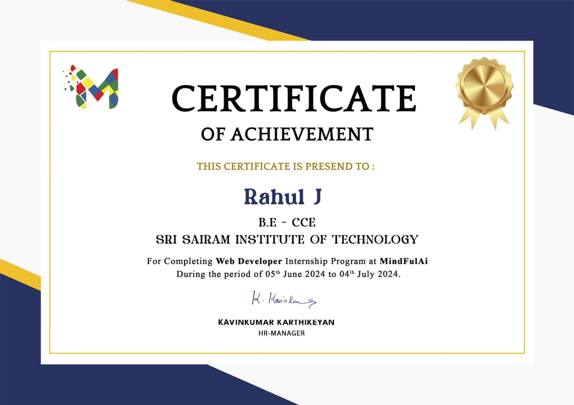

**CHAPTER - 7 RESULT & CONCLUSION**

* 1. **RESULT**

The culmination of our efforts during the internship period resulted in the successful creation of a company landing page. Through meticulous design, coordinated project management, and innovative ideation, we developed a product that seamlessly integrates user-friendly interfaces with robust functionality. The landing page prototype showcases both front-end and back-end architecture, ensuring an intuitive experience for users. Additionally, our focus on error handling and code organization enhances the reliability and efficiency of the system. By prioritizing user engagement and security, we have developed a versatile solution that meets the diverse needs of the company's clients and stakeholders.

* 1. **CONCLUSION**

The internship provided an invaluable opportunity for career exploration and development, allowing us to acquire new skills and practical experience. The representatives offered us the chance to work on product innovation and development at their incubation center. They provided the necessary resources and guidance to help us design and deploy the company landing page in real-world circumstances. This experience enabled us to learn new technologies and methodologies related to web development and practical implementation, significantly contributing to our professional growth and readiness for future challenges in the field.